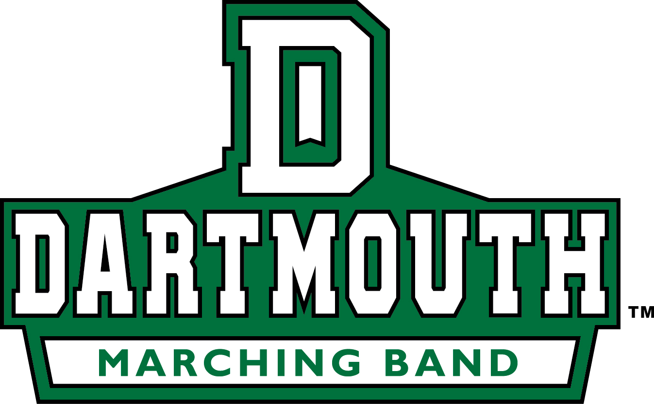

* Sold by the Dartmouth
* College Marching Band

Want one? Email the DCMB or stop by our tables around campus

Dartmouth.College.Marching.Band@Dartmouth.com

Only $60 and available immediately

($2 convenience fee if paying with credit card)

Accepting Visa, Mastercard, Discover, AMEX, PayPal

DASH, cash and checks (payable to ‘Dartmouth College’)

## Made from 100% Cotton – soft and comfortable; ideal for any weather.

2018 Class Sweaters

# Show your pride as a member of the Class of 2018